**Microprocessor and Computer Architecture (MPCA) Laboratory  
UE20CS252 4th Semester,  
Academic Year 2021-22**

**Week 5**

|  |  |  |
| --- | --- | --- |
| **Vanshika Goel** | **PES1UG20CS484** | **H Section** |

1. Write a program in ARM7TDMI-ISA to multiply 2 matrices of order3.

i.e., implement c[i][j]=c[i][j] + a[i][j] x b[i][j].

a. Use MLA instruction

b. Use MUL instruction

.DATA

A:.WORD 1,2,3,4,5,6,7,8,9

B:.WORD 1,2,3,4,5,6,7,8,9

C:.WORD 0,0,0,0,0,0,0,0,0

.TEXT

LDR R0,=A

LDR R1,=B

LDR R2,=C

MOV R5,#0

MOV R6,#0

MOV R7,#0

MOV R8,#0

LOOP:

LDR R3,[R0],#4

LDR R4,[R1],#12

MLA R8,R3,R4,R8

ADD R5,R5,#1

CMP R5,#3

BNE LOOP

STR R8,[R2],#4

BL LOOP1

LOOP1:

LDR R3,[R0,#-12]!

LDR R4,[R1,#-32]!

MOV R8,#0

MOV R5,#0

ADD R6,R6,#1

CMP R6,#3

BLT LOOP

LOOP2:

LDR R3,[R0,#12]!

LDR R4,[R1,#-12]!

MOV R8,#0

MOV R5,#0

MOV R6,#0

ADD R7,R7,#1

CMP R7,#3

BNE LOOP

SWI 0X011

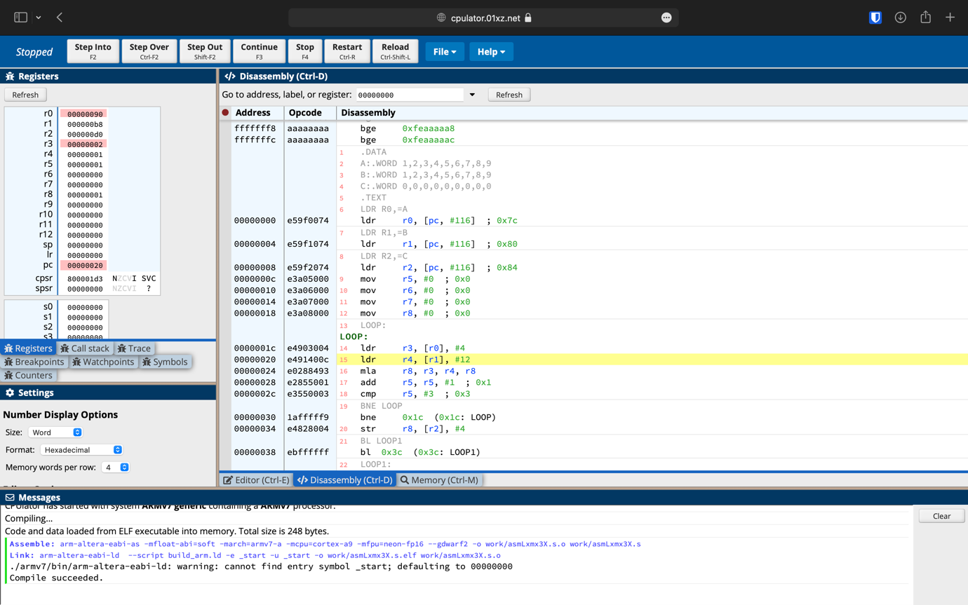

.DATA

A:.WORD 1,2,3,4,5,6,7,8,9

B:.WORD 1,2,3,4,5,6,7,8,9

C:.WORD 0,0,0,0,0,0,0,0,0

.TEXT

LDR R0,=A

LDR R1,=B

LDR R2,=C

LOOP:

LDR R3,[R0],#4

LDR R4,[R1],#12

MUL R8,R3,R4

ADD R9,R9,R8

ADD R5,R5,#1

CMP R5,#3

BNE LOOP

STR R9,[R2],#4

BL LOOP1

LOOP1:

LDR R3,[R0,#-12]!

LDR R4,[R1,#-32]!

MOV R8,#0

MOV R9,#0

MOV R5,#0

ADD R6,R6,#1

CMP R6,#3

BLT LOOP

LOOP2:

LDR R3,[R0,#12]!

LDR R4,[R1,#-12]!

MOV R8,#0

MOV R9,#0

MOV R5,#0

MOV R6,#0

ADD R7,R7,#1

CMP R7,#3

BNE LOOP

SWI 0X001

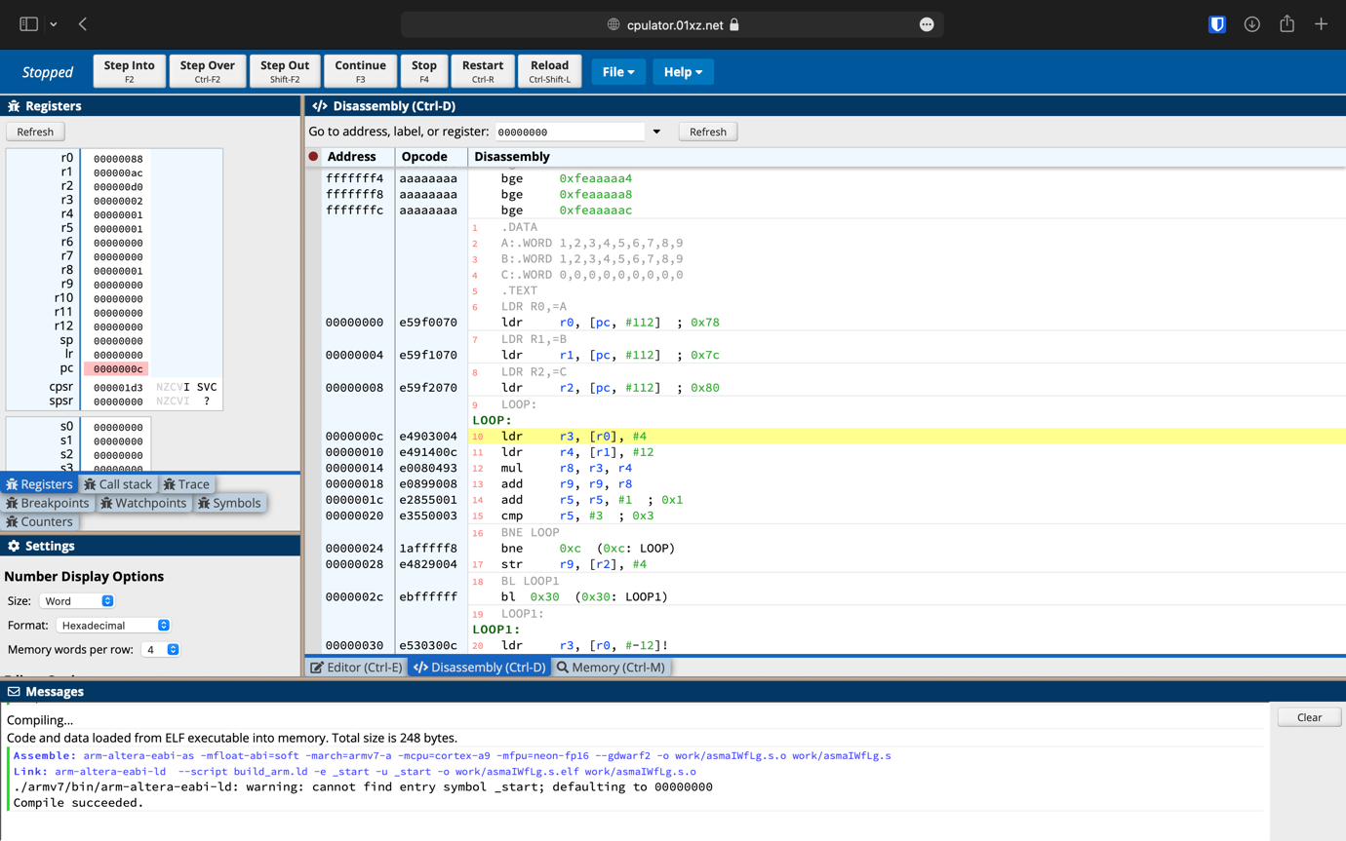

2. Write a program in ARM7TDMI-ISA to find the NORM of a square matrix of

order n.

.DATA

A: .WORD 1,3,5,7,9,11,13,15,17

B: .WORD 0,0,0

C: .WORD 0

.TEXT

LDR R0,=A

LDR R1,=B

LDR R2,=C

MOV R3,#0

MOV R4,#0

MOV R10,#3

MOV R5,#0

MOV R8,#0

SUB R8,R8,#1

LOOP:MLA R11,R4,R10,R3

MOV R11,R11,LSL #2

LDR R6,[R0,R11]

CMP R6,#0

MULMI R6,R8,R6

ADD R5,R5,R6

ADD R4,R4,#1

CMP R4,#3

BNE LOOP

MOV R7,R3,LSL #2

STR R5,[R1,R7]

MOV R4,#0

ADD R3,R3,#1

MOV R5,#0

CMP R3,#3

BNE LOOP

MOV R3,#0

MOV R4,#0

MOV R5,#0

LDR R3,[R1,R4]

MAX:ADD R4,R4,#4

LDR R6,[R1,R4]

CMP R3,R6

MOVLT R3,R6

ADD R5,R5,#1

CMP R5,#2

BNE MAX

STR R3,[R2]

SWI 0X011

.END

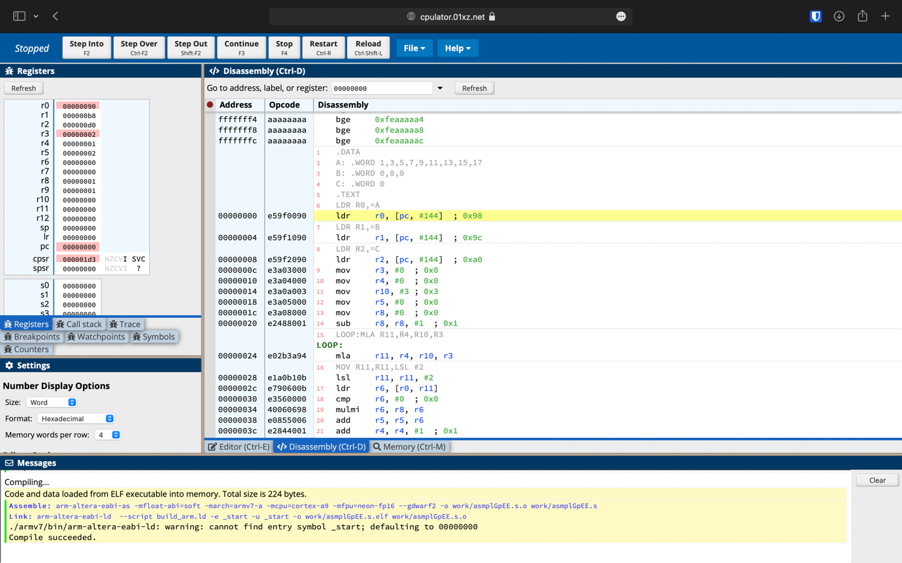

3. Write a program in ARM7TDMI-ISA to find the ROWSUM of a matrix.

.DATA

A:.WORD 1,2,3,4,5,6,7,8,9 ;MATRIX 1ST ELEMENT OFFSET 0 THEN 4, 8, 12 ETC

C:.WORD 0,0,0

.TEXT

LDR R0,=A

LDR R2,=C

MOV R3,#0

MOV R4,#0

MOV R10,#3

MOV R7,#0

LOOP1:

MLA R11,R3,R10,R4

MOV R11, R11, LSL #2

LDR R5,[R0,R11]

ADD R7, R7, R5

ADD R4, R4,#1

CMP R4, #3

BNE LOOP1

MOV R4,#0

MLA R11,R3,R10,R4

MOV R11, R11, LSL #2

STR R7,[R2,R11]

MOV R7,#0

ADD R3, R3, #1

CMP R3, #3

BNE LOOP1

SWI 0x011

